Vol. 16, No. 6  pp. 1-33  November & December 2025  Received: 17 December 2022  Received in revised form: 9 April 2023  Accepted: 25 April 2023 | How Trends and Topics Reflect the Evolution of Translation Studies as an Academic Field of Study: A Scientometrics Study  Nematullah Shomoossi, Mehrdad Vasheghani Farahani²*,  Somayeh Ghaffari Heshajin³, & Abdurrashid Khazaei Feizabad⁴  Abstract  Translation Studies seems to in establishing itself as an area of inquiry for scholars. Patterns of flourishing this discipline with its diverse audience are not well studied, though. The present study employed scientometric and bibliometric analyses to identify and assess topics and trends of Translation Studies as evidence of evolution over the course of time. Documents (from 1931 to 2021) were extracted from Scopus to examine relevant indicators, including document types, top journals, authors’ networks, institutes/universities, organizational support, countries and interdisciplinary contributions. In addition, VOSviewer, network and cluster density visualization and word co-occurrences were utilized to analyze and evaluate the development of the field. The analyses revealed that over a 90-year time span (1931-2021), 13916 documents were published by 21509 authors from 16323 institutes/universities that contributed to the scientific development of Translation Studies. Authors’ cooperation from 124 countries emerged in four clusters led by the US, the UK, Spain and China. In its course of development, Translation Studies witnessed a remarkable proliferation of documents since the 2000s. Relevant topics were demonstrated by keywords analysis, and interrelationships of Translation Studies with other disciplines were explored. The findings offer analyses of trends and topics in Translation Studies, as evidence of scientific evolution, attested by the interdisciplinary contributions and bibliometric findings.
 | Keywords: translation studies, science evolution, research topics, trends, research Performance, scientometrics, bibliometrics, word co-occurrence analysis

- Introduction
Translation, as a growing field, has two different phases. One phase refers to translation as a kind of job and craft - which has quite an ancient tradition, history and record - and another phase refers to translation as a science or academic field of study which is entirely new and progressive (Munday, 2016; Vasheghani Farahani & Pahlevanzade Fini, 2023). In other words, although translation and transferring the message from one language to another has a history as long as human language has existed and is “as old as Bible tower” (Gentzler, 1990, p.1), the scientific investigation of translation is quite a new area of inquiry in the sense that “throughout history, written and spoken have played a crucial role in inter-human communication…yet the study of translation as an academic subject only really began in the second half of the twentieth century” (Munday, 2012, p. 10). In the English-speaking world, this discipline is now generally known as ‘Translation Studies’.
The growth of Translation Studies as a distinct university major occurred so fast that most European universities turned to design different programs of this major; “offering a variety of certificates and degrees - undergraduate and graduate - training not only professional translators, but also scholar-teachers of translation and of foreign languages and literatures” (Venuti, 2000, p.1). As a matter of fact, in the last decade of the 20th century, Translation Studies began to prove itself as a thriving discipline and a new field of inquiry which had to be considered seriously by academia (Gentzler, 2014). As a result, many students from all around the world found their ways through this thought-provoking and fast-growing field of study and many materials began to emerge out of Translation Studies to lead the way for further research. In other words,
while its status as a discipline was less and less in question, the sheer proliferation of discourses on translation made it necessary to take stock of that discipline. Thus, dictionaries, encyclopedias and anthologies began to appear with an astonishing frequency in an attempt to guide, but also channel, the reading in the field (Kuhiwczak & Littau, 2007, p. 2).

Although Translation Studies, at the onset of the 21st century, has established itself as an academically independent area of research, it seems that less coherent and systematic attempts have been made to determine its trends and developmental patterns (Vasheghani Farahani & Vahid Dastjerdi, 2019). This scarcity of research has led to the dispersion of research in diverse branches; ranging from “literary translation to community interpreting through technical translation, legal translation, Bible translation, localization, audiovisual translation, conference interpreting, signed language interpreting and court interpreting, to list just a few” (Gile, 2015, pp.1-2). However, this does not seem unlikely of a scientific field because science appears as a complex system with dynamic development over time (Coccia, 2020a; Zou et al., 2024)
In order to study the quantitative profile of research in Translation Studies, the potential of scientometrics and bibliometrics is underutilized (Gile, 2015), in spite of the fact that few studies in the past decade have addressed the research trends of Translation Studies in general (Dong & Chen, 2015; Wang et al., 2019) or in machine translation in particular (Gupta & Dhawan, 2019, Yang & Husin, 2024). Indeed, scientometrics, coined by Nalimov in 1971, is concerned with the quantitative tracking, production and publication of scientific information as an effort to gain a better insight into scientific research in a specific field of study (Miners & Leydesdorff, 2015). On the other hand, bibliographics, first introduced by Pritchard (1969), is defined as the quantification of published materials such as bibliographic units. To put it another way, bibliographics is the study of relationships between numbers and patterns in bibliographic data, i.e., the number of papers, development of literature and patterns of library and database usage (Chellappandi & Vijayakumar, 2018, p.5). Moreover, co-occurrence is the way of “mapping and understanding the structures in the underlying document sets” (Leydesdorff & Vaughan, 2006, p. 1).
With regard to the critical impact of science evolution in explaining human progress (Coccia & Bellitto, 2018), and despite recent developments in evaluating trends in Translation Studies (Grbić & Pöllabauer, 2008; Warner, 2000), this under-investigated area of inquiry still deserves more attention of the academia. In light of this, the present study was a concretized effort to explore the topics, trends and research performance of Translation Studies scholars by addressing its developmental patterns; using scientometric, bibliometric and co-occurrence methods in relevant literature during the past century. The results are expected to provide readers with a global image of the scholarly production and evolution of Translation Studies.

- Review of the related Literature
The field of Scientometrics in Translation Studies is nascent and there are reportedly not many works in this strand of study. As a case in point, Zhu and Aryadoust (2022) investigated the growth of Translation Studies by applying Scientometrics. For this reason, they identified 12 different documents and co-citations. The results indicated that in the realm of Translation Studies, 12 major clusters were identified, including translation competence, translation in conflict zones, translator training, collaborative translation, translation and society, language policy, post-editing and revision, media translation, the translation profession, and web localization.
In much the same way, Zanettin et al. (2015) investigated the trajectory of Translation Studies and its subfields through bibliographic methods. To achieve this objective, they analyzed Translation Studies abstracts from 1998 and took stock of 16000 abstracts including articles, abstracts and dissertations in the field of Translation Studies. The analysis of the keywords unveiled the fact that from the 1980s and in concert with the growth of cultural turns in Translation Studies; a clear propensity toward Translation and Cultural Studies can be observed.
In the same vein, Yamamoto (2018) launched research with the purpose of identifying the trends, trajectories and features of accumulated research in the discipline of Translation Studies in Thailand. To this objective, he gathered the relevant data from Thai-Journal Citation Index Centre and scrutinized 144 articles. The analysis of the papers reflected that half of the papers were in the domain of translation methodologies and techniques followed by educational perspective. In addition, it was found out that most of the papers were published in interdisciplinary journals.

In another study, Wang et al. (2019) unearthed the trajectory of Translation Studies in China and international academia. Through quantitative analysis and analyzing database, they found that the topic of Translation Studies has not aroused sufficiently in China and it leaves a lot to be desired.
By the same token, Rovira-Esteva et al. (2020) ran research in an effort to unveil co-authorship practices in Translation Studies. For running this study, they applied a scientometric methodology by retrieving data from BITRA (Bibliography of Interpreting and Translation), which contains over 69,000 TS records over a 45-year time span. The analysis illustrated that in overall the number of co-authored in increasing and that the number of co-authors in Translation Studies is higher than those of the other majors in humanities. However, the analysis indicated that the ratio of international collaboration is very low (10%).
In a contemporary study, Vasserman (2022) studied the growth Andrei Fedorov’s research publication who is a preeminent Russian translator. For this objective, he used Fedorov’s manuscript repository in the Central State center of Literature and Art in the city of Saint Petersburg. By using a micro-level scientometric method and analyzing Fedorov’s publication outputs and of citations to his works, he demonstrated that Fedorov published 195 works during his educational life. In addition, there were more than 7,718 citations to his works. The results indicated that Fedorov was the most preeminent and cited researcher in the field of Translation Studies in Russian.

- Methodology
Scientometrics relies on the existence of usable and interpretable data (Gile, 2015; Wu & Amzah, 2023). Having taken this into account, the present study was based on bibliometric and scientometric methods, with the intention of investigating the current status of scientific production in ‘Translation Studies’, indexed in Scopus as of March 3rd, 2021. A search strategy, stated below, was fed into Scopus, and the resulting comma-separated values (CSV) data were processed in VOSviewer which is used to create bibliometric networks including researchers, publications, journals and citations (Wang et al., 2019). Because of Scopus limitations on its volume of search output, the extracted documents were organized into nine separate files according to their publication year. In addition, figures and Excel files from Scopus were extracted by type and frequency of documents, source, affiliation, year of publication, author, country, subject area and sponsor funding.

  - The Search Strategy
For conducting the investigation, a search strategy was designed to cover “title, abstract and keywords”, and to examine documents related to Translation Studies. The keywords included in the search strategy were selected by studying the relevant literature and consensus among the authors. The search strategy was as follows:
(TITLE-ABS-KEY (translation) AND TITLE-ABS-KEY (studies) OR TITLE-ABS-KEY (translation) OR TITLE-ABS-KEY (interpreting) AND TITLE-ABS-KEY (translator) OR TITLE-ABS-KEY (interpreter) AND TITLE-ABS-KEY (translation) OR TITLE-ABS-KEY (process) OR TITLE-ABS-KEY (assessment) OR TITLE-ABS-KEY (models) OR TITLE-ABS-KEY (computer-assisted) OR TITLE-ABS-KEY (competence) OR TITLE-ABS-KEY (literary) OR TITLE-ABS-KEY (criticism) OR TITLE-ABS-KEY (evaluation) OR TITLE-ABS-KEY (strategy)
Various analyses were conducted in VOSviewer, which is a software for visualizing bibliometric data and networks. The analyses included co-authorship, keywords co-occurrence, bibliographic coupling, co-citation, top journals, countries and universities/institutions collaborating in publication, for investigating the current status of scientific production in Translation Studies. In the analyses, the full counting technique is used, and the findings are presented below in sequence.

  - Analysis of Keywords Co-occurrence
Co-occurrence analysis was used to identify the most important research topics. The frequency of a keyword indicates its relative significance. The frequency of two words co-occurring in a single document reveals their intense relationship, and is used in the analyses for portraying the development of an area in a scientific field. Therefore, an investigation of co-occurring concepts/keywords in documents can elucidate prominent trends and topics in a discipline (Vinkler, 2010). The extracted information was used for both portraying the maps and determining the topics and trends in Translation Studies literature.
In the present study, out of 43474 keywords extracted, 204 words with at least 50 occurrence cases were selected. It must be noted that the cut-off points 50 was suggested and agreed upon because too many keywords emerged during the first phase and the inclusion of more salient keywords relied on their frequency; those keywords which were less frequent in databases were left out so that 204 remaining ones became more manageable for analysis purposes. Generally, the relationship between two topics can be traced by their appearance in documents. Such a relationship may be acknowledged in documents to demonstrate their intense relationship in an area of science, which also reflects the earlier theories or research results. It further helps bond a topic with relevant literature in the field.

  - Network Visualization
VOSviewer 1.6.15 was used for scientific mapping and clustering the themes in order to determine topics and trends (van Eck & Waltman, 2020). Visualization maps contribute to our understanding of the general image of research in a certain branch of science, and to the analysis of trends and scientific evolution over a certain period of time (Murgado-Armenteros et al, 2015). It facilitates identifying areas of research on a certain topic and their interrelationships (Van den Besselaar & Heimeriks, 2006). As stated in VOSviewer Manual, in the network visualization, items are represented by their label and by a circle, where the weight of the item determines the size of labels and circles. Simply put, the higher the weight of an item, the larger the label and the circle of the item. In addition, the color of an item is determined by the cluster to which the item belongs, and lines between the items represent respective links (van Eck & Waltman, 2020).
  - Cluster Density Visualization
To prepare the authors’ and countries’ networks, the search results were entered into VOSviewer software to obtain the visualization. Cluster density networks were drawn to visualize the trends of Translation Studies, where the color of a point in the visualization reflects the colors of different clusters, and number of items belonging to that cluster determines the weight given to the color of the cluster; the weight of an item is also taken into account (Van Eck & Waltman, 2020).

- Results
In the present study, 13916 documents were retrieved by the searach strategy as described in the Methods section. The oldest document dates back to 1931, which was cited as an article in the Modern Language Journal titled as “Macbeth in the Hands of French and Spanish Translators”, (Manchester, 1931). Out of these 13916 documents, 7972 documents were research articles (57.3%). Second to articles, conference papers (22.3%) seem to be of almost the same weight as all other published resources, excluding articles: reviews (11.2%), book chapters (6.2%), and books (2.2%). The least frequent documents included editorial materials, conference reviews, notes, short surveys, erratum, letters, reports and undefined documents (1.7% altogether) (Table 1).

Table 1
Document Types in Translation Studies
Document types | Frequency | Percentage
Articles | 7972 | 57.3
Conference Papers | 3105 | 22.3
Reviews | 1556 | 11.2
Book Chapters | 863 | 6.2
Books | 301 | 2.2
Editorial Materials | 32 | 0.2
Conference Reviews | 30 | 0.2
Notes | 22 | 0.2
Short Surveys | 16 | 0.1
Erratum | 6 | 0.03
Letters | 6 | 0.03
Reports | 3 | 0.02
Undefined documents | 4 | 0.02
Total | 13916 | 100

These documents appeared in 4933 scholarly sources and journals of Translation Studies including, but not limited to, Babel, Meta, Perspectives in Translatology, Translator, Target, Journal of Specialized Translation, Translation and Interpreting Journal, Translation and Interpreting, Lebende Sprachen, Interpreter and Translator Trainer, and Translation Studies, among others. In this regard, top 30 journals hosted about one quarter (24.39%) of the publications in translation studies (Table 2), a phenomenon that follows Bradford’s law (a pattern first described by Samuel C. Bradford in 1934 which emphasizes the importance the core journals in a field) (Chongde & Zhe, 1998). The first row in Table 2 also lists New Voices in Translation Studies as the top source, which contains 12626 volumes in this series published from 1973 to 2021, mainly including articles on machine translation, matching to our search strategy.

Table 2
Top 30 Journals Publishing Translation Studies Documents
Rank | Source | Frequency | Percentage
1 | New Voices in Translation Studies | 580
2 | Babel | 334
3 | Meta | 267
4 | Perspectives: Studies in Translatology | 234
5 | Translator | 180
6 | Target | 172
7 | Journal of Specialised Translation | 159
8 | Interpreter and Translator Trainer | 133
9 | Translation Studies | 88
10 | Intralinea | 75
11 | Perspectives Studies In Translation Theory And Practice | 75
12 | Across Languages And Cultures | 74
13 | Ceur Workshop Proceedings | 72
14 | Quaderns | 68
15 | Translation and Interpreting Studies | 68
16 | Ttr Traduction Terminologie Et Redaction | 68
17 | Sendebar | 66
18 | Lebende Sprachen | 64
19 | Mutatis Mutandis | 64
20 | ACM SIGPLAN Notices | 62
21 | Translation and Interpreting | 62
22 | Theory and Practice In Language Studies | 59
23 | Przekladaniec | 57
24 | Trans | 55
25 | ACM International Conference Proceeding Series | 52
26 | Meta Canada | 52
27 | Machine Translation | 50
28 | Advances in Intelligent Systems and Computing | 49
29 | Hermeneus | 47
30 | Linguistica Antverpiensia | 46
Total |  | 3394 | 24.39

As for the authors, 21509 authors contributed to the production of 13916 documents, representing 1.55 authors per document, indicating a mild propensity for teamwork in producing the documents. To achieve minimum clusters, five clusters were drawn. Cluster one (red) contains 35 items, with Mona Baker as the highly cited core (1343 citations) and total link strength of 52; followed by Albir A.H. (280 citations and total link strength of 16, and Munday J. (260 citations) and total link strength of 8. Cluster two (green) contains 30 items, led by Anthony Pym (563 citations) and total link strength of 38, followed by Olohan M. (382 citations) and total link strength of 51, and O’Brien S. (235 citations) and total link strength of 42. Cluster three (blue) contains 24 items, led by Davidson J.W. (244 citations) and total link strength of 12, followed by Hsu, W.C. (220 citations) and total link strength of 90, and Yew, P.C. (162 citations) and total link strength of 59. Cluster four (yellow) contains 22 items, led by Zhang H. (637 citations) and total link strength of 5, followed by Koehn P. (408 citations) and total link strength of 43, and Casacuberta F. (273 citations) and total link strength of 59. Cluster five (violet) contains only 10 items, led by Nord C. (206 citations) and total link strength of 23, followed by Wang Y. (201 citations) and total link strength of 30, and Wang H. (84 citations) and total link strength of 75 (see clusters of authors’ cooperation in Figure 1 below).

Figure 1
Network Visualization of Authors’ Cooperation in Joint Research
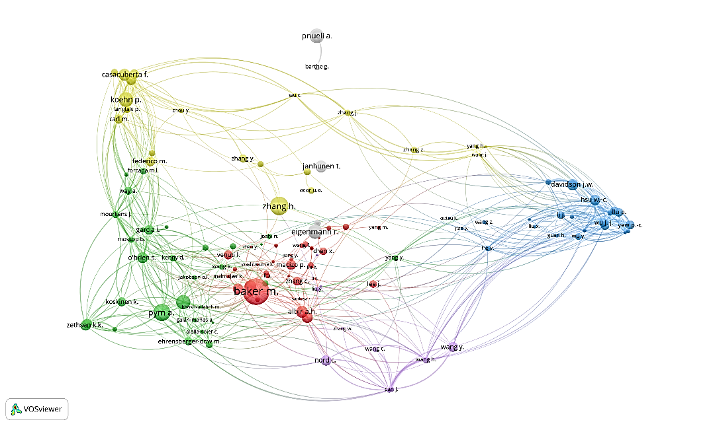

As regards the role of institutes/universities, 16323 institutes/universities were detected as the authors’ affiliations who contributed to the production of documents on Translation Studies. The highest contributions were from Universitat Autònoma de Barcelona (0.9%), University of Manchester (0.7%), and Universidad Jaume I (0.7%). The contribution of top 25 institutes/universities (with minimum 50 documents listed in Scopus) accounted for 12.3% of the documents (Table 3).

Table 3
Top 25 Affiliations of the Authors in Translation Studies
Rank | Institute | Frequency | Percent
1 | Universitat Autònoma de Barcelona | 127 | 0.9
2 | The University of Manchester | 104 | 0.7
3 | Universidad Jaume I | 92 | 0.7
4 | Universidad de Granada | 90 | 0.6
5 | Dublin City University | 88 | 0.6
6 | University of Montreal | 78 | 0.6
7 | Uniwersytet im. Adama Mickiewicza w Poznaniu | 72 | 0.5
8 | University College London | 71 | 0.5
9 | KU Leuven | 65 | 0.5
10 | University of Ottawa, Canada | 65 | 0.5
11 | University of Warsaw | 64 | 0.5
12 | University of Leeds | 63 | 0.5
13 | The University of Edinburgh | 62 | 0.4
14 | Université de Genève | 61 | 0.4
15 | Universidade de Vigo | 61 | 0.4
16 | Universiteit Gent | 61 | 0.4
17 | Aarhus Universitet | 59 | 0.4
18 | Universitat Pompeu Fabra Barcelona | 59 | 0.4
19 | Universidad de Malaga | 58 | 0.4
20 | Universidad Pablo de Olavide | 56 | 0.4
21 | Alma Mater Studiorum Università di Bologna | 54 | 0.4
22 | Carnegie Mellon University | 53 | 0.4
23 | CNRS Centre National de la Recherche Scientifique | 52 | 0.4
24 | Universitat d'Alacant | 52 | 0.4
25 | Russian Academy of Sciences | 50 | 0.4
Total |  | 1717 | 12.3

Another aspect which was investigated was the acquisition of funds and academic support from organizations and granting bodies; the analysis showed that 159 granting bodies/organizations aided 1484 studies (%10.66) of the 13916 documents listed in Scopus. Table 4 presents the first 20 organizations/granting bodies, accounting for 753 (out of 13916) documents (%5.3).

Table 4
Top 20 Granting Bodies/Organizations in TS Research
 | Sponsoring Organizations | Frequency | Percentage
1 | National Science Foundation | 1146 | 1.1
2 | National Natural Science Foundation of China | 880 | 0.6
3 | European Commission | 556 | 0.4
4 | Japan Society for the Promotion of Science | 553 | 0.4
5 | Seventh Framework Programme | 444 | 0.3
6 | Arts and Humanities Research Council | 338 | 0.3
7 | Engineering and Physical Sciences Research Council | 337 | 0.3
8 | Horizon 2020 Framework Programme | 333 | 0.2
9 | Defense Advanced Research Projects Agency | 229 | 0.2
10 | Ministerio de Economía y Competitividad | 229 | 0.2
11 | European Regional Development Fund | 227 | 0.2
12 | Science Foundation Ireland | 225 | 0.2
13 | Deutsche Forschungsgemeinschaft | 223 | 0.2
14 | Conselho Nacional de Desenvolvimento Científico e Tecnológico | 220 | 0.1
15 | Natural Sciences and Engineering Research Council of Canada | 220 | 0.1
16 | Russian Foundation for Basic Research | 220 | 0.1
17 | Coordenação de Aperfeiçoamento de Pessoal de Nível Superior | 119 | 0.1
18 | European Research Council | 18 | 0.1
19 | Ministerio de Ciencia e Innovación | 18 | 0.1
20 | National Research Foundation of Korea | 18 | 0.1
Total |  | 753 | %5.3

With respect to country-level contributions, the authors were affiliated with institutions in 124 countries. A total of 988 documents lacked definable author nationality, most likely corresponding to book chapters, editorial materials, notes, errata, letters, reports, or other unspecified document types. The United States accounted for the largest share of publications (n = 2300), followed by Spain (n = 1318) and the United Kingdom (n = 1233). Collectively, the top 20 countries produced 80.4% of all documents, whereas the remaining 104 countries contributed approximately one-fifth of the total output (Table 5).

Table 5
Contribution of Countries to the Production of TS Documents in Scopus
Rank | Country | Documents | Percent
1 | United States | 2300 | 16.5
2 | Spain | 1318 | 9.5
3 | United Kingdom | 1233 | 8.9
4 | China | 802 | 5.8
5 | Germany | 599 | 4.3
6 | France | 574 | 4.1
7 | Canada | 533 | 3.8
8 | Italy | 459 | 3.3
9 | Russian Federation | 428 | 3.1
10 | Poland | 414 | 3
11 | Brazil | 347 | 2.5
12 | Australia | 336 | 2.4
13 | Japan | 321 | 2.3
14 | India | 254 | 1.8
15 | Belgium | 245 | 1.8
16 | South Africa | 224 | 1.6
17 | Iran | 203 | 1.5
18 | Switzerland | 196 | 1.4
19 | Hong Kong | 193 | 1.4
20 | South Korea | 192 | 1.4
Total |  | 11171 | 80.4

  - Network and Cluster Density Visualization
The cooperation between researchers from different countries was also investigated. On the left, four cluster nodes can be detected which are led by the US, the UK, Spain and China (Figure 2). Other countries cooperating with major cluster nodes are visible too. The bigger the circle, the higher the cooperation rate of that country/territory with other countries. For further resolution, number of bonds are minimized to keep the stronger ones and to render a more crystalized image.
Figure 2
Network (Left) and Cluster Density Visualization (Right) for the Cooperation of Countries
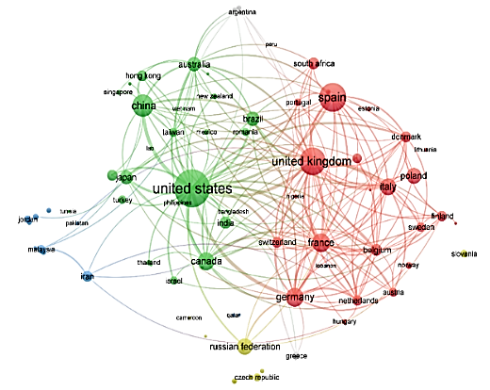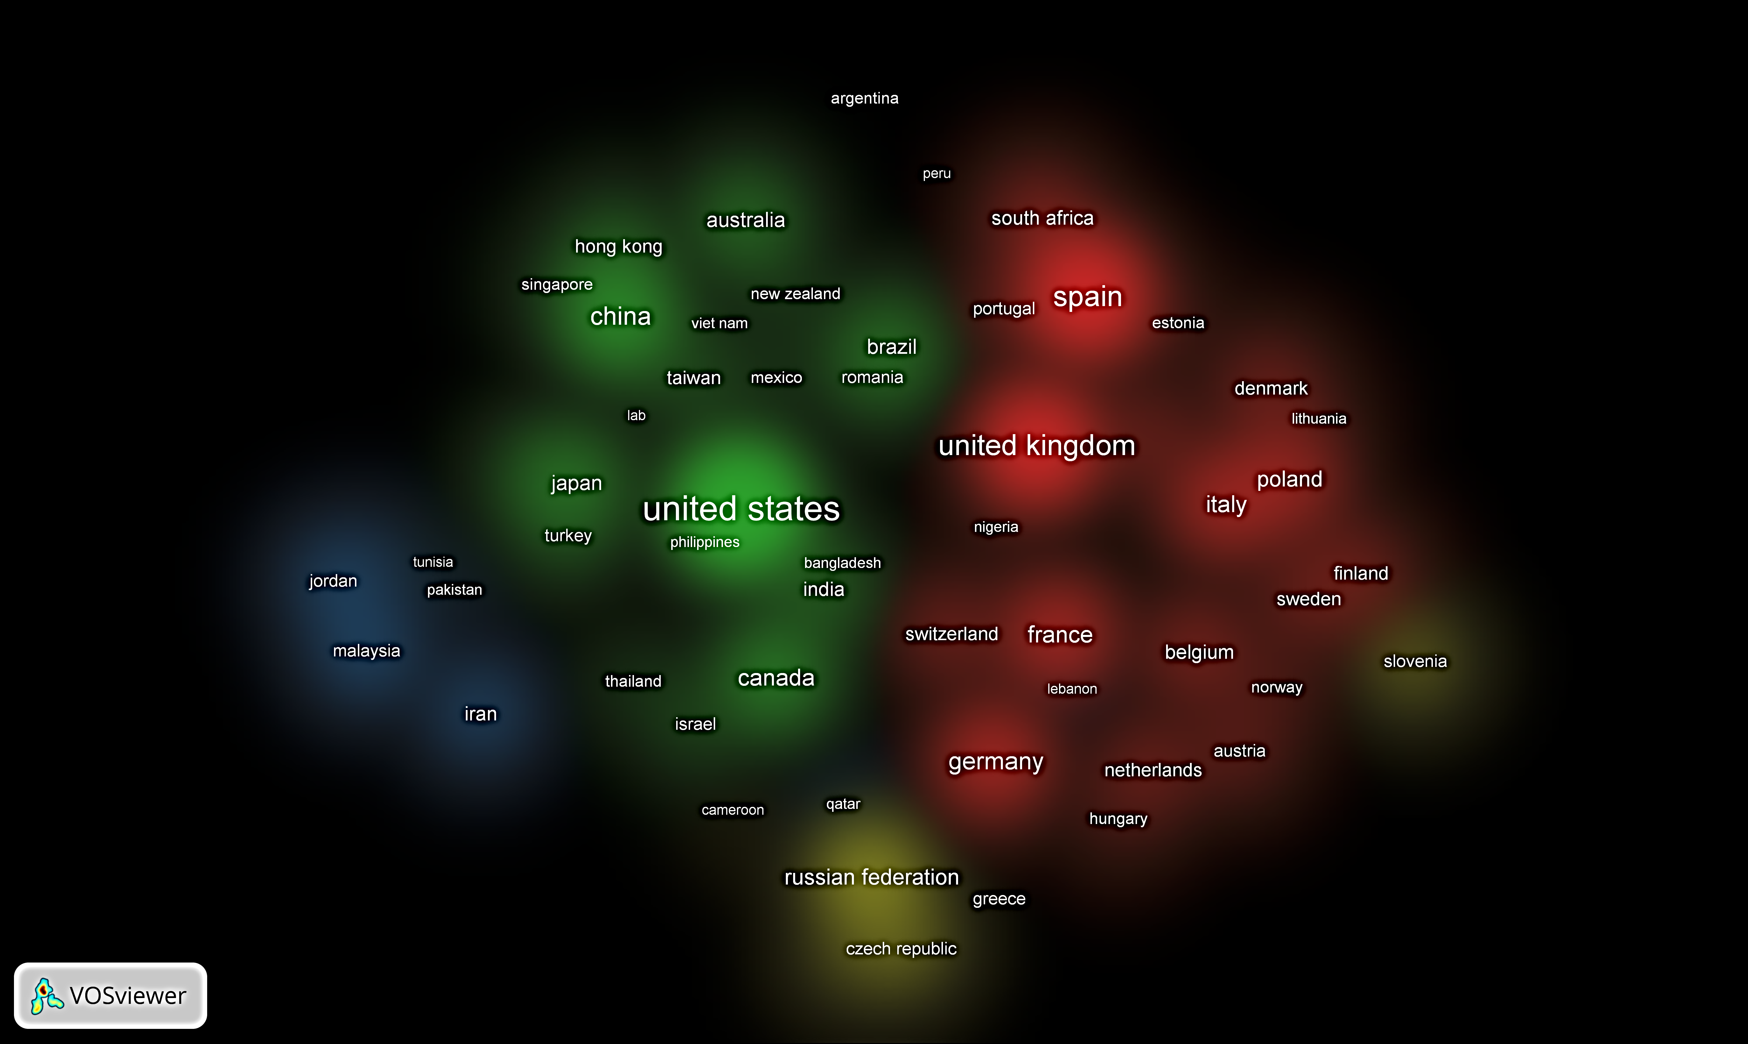

  - Trends Analysis
For investigating the trends over the past 90 years, in addition to network and cluster density maps, Figure 3 below was drawn to visualize a general view of the relevant publication. This simple linear figure of the field shows the development of this field from 1931 to 2021, which is distinctly divisible into three stages. The first 40 years may reflect the infancy period from 1931 to 1970, during which 99 documents (0.71%) were produced and published. The second stage is a 30-year span of slow development period from 1972 to 2000, during which 1430 documents (10.28%) were published; and the third stage is a 20-year period of booming growth from 2001 to 2021, during which 12387 documents (89.01%) have been published. In fact, the number of publications has grown exponentially during the third period (Figure 3).

Figure 3
Publication of TS Documents by Year

  - Keywords Co-occurrence Analysis
Another index for investignting the trends in Translation Studies is the keywords co-occurrence in the documents (Chen, Chen, Wu, Xie & Li, 2016). It is used to explore the themes and their logical relationship in the corpus as an effort to portray the conceptual networks in various aspects of a discipline (Ravikumar, Agrahari & Singh, 2014). The investigation of the most frequent keywords co-occurrence analysis signifies that from among the keywords, the most frequent themes were program translators, translation and translation languages, whereas machine translation and computer programing languages were the least frequent ones. In fact, the 20 most frequent keywords accounted for 28.4% of the total.

Table 6
Frequency and Percentage of the 20 Most Frequent Keywords
Keywords | Frequency | Percentage
Program translators | 1816 | 4.2
Translation | 1772 | 4.1
Translation (languages) | 1304 | 3
Human | 852 | 0.8
Article | 721 | 1.7
Computational linguistics | 630 | 1.5
Humans | 610 | 1.4
Semantics | 554 | 1.3
Language | 497 | 1.2
Computer aided language translation | 466 | 1.1
Female | 461 | 1.1
Male | 437 | 1
Machine translations | 425 | 1
Adult | 386 | 0.9
Questionnaire | 356 | 0.8
Program compilers | 345 | 0.8
Linguistics | 341 | 0.8
Translations | 322 | 0.7
Machine translation | 307 | 0.7
Computer programming languages | 271 | 0.6
Total | 12873 | 28.4

Moreover, Figure 4 below illustrates the netwrok visualization (Left) and clusters density (Right) visualization, where keywords co-occurrence emerged in three clusters. The most trendy co-occurring topics are shown to be translators, translation, human elements, computational linguistics, semantics, language, computer-aided language translation, gender, machine translations, program compilers, and linguistics. However, the three cluster are different by nature. Cluster one (red) contains 111 items, led by program translators (total link strength 6309, 1816 occurrence cases and 146 links), followed by translation (languages) (total link strength 5015, 1304 occurrence cases and 159 links), and computational linguistics (total link strength 3029, 630 occurrence cases and 138 links). Second cluster (green) contains 50 items, led by language (total link strength 4489, 497 occurrence cases and 124 links), followed by translating (total link strength 2867, 1772 occurrence cases and 187 links), and translating (total link strength 2834, 268 occurrence cases and 107 links). The third cluster (blue) contains 43 items, led by human (total link strength 8953, 852 occurrence cases and 118 links), followed by humans (total link strength 7299, 610 occurrence cases and 115 links), and article (total link strength 7182, 721 occurrence cases and 128 links).

Figure 4
Netwrok (Left) and Clusters Density (Right) Visualizations of Keywords Co-occurrence in Translation Studies
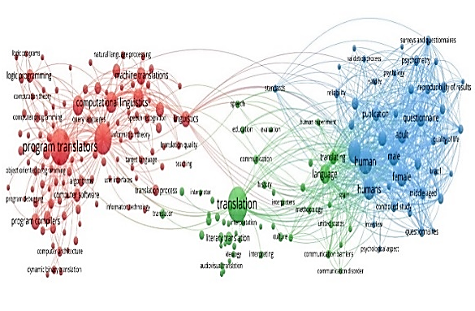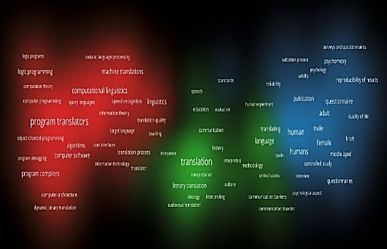

  - Contribution from Other Disciplines
A further analysis was conducted on the subject area of the documents; the results revealed an interestingly long list of subject areas from other disciplines. The list confirms the interdisciplinary nature and need for and application of translation as a profession on the one hand, and relevant research studies to apply in other areas of knowledge, on the other hand. Figure 5 below depicts a list as diverse as Arts and Humanities, Social Sciences, Computer Science, Engineering, Medicine, Psychology, Physics and Astronomy, Business, Management and Accounting, Environmental Science, Pharmacology, Toxicology and Pharmaceutics, Dentistry and Veterinary sciences, among others.

Figure 5
Publication by Subject Areas
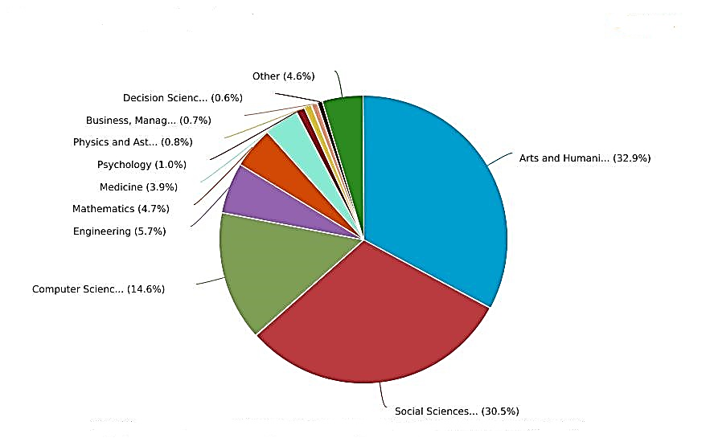

5. Discussion
The present study contributes to a nuanced understanding of the evolution of Translation Studies over the course of time. Science may be generally defined as a complex system with dynamic elements tending to develop over the course of time (Coccia, 2020a). Cohen and Lloyd (2014) particularly defined “academic/scientific disciplines as an array of academic studies focusing on a self-imposed limited field of knowledge” (p.65). In order to discuss the findings, this study benefited from the definitions of science, on the one hand, and theories of science evolution, on the other. In fact, the results of the present study were examined by analyzing the topics and trends the topics and trends in Translation Studies, as an academic discipline, to address its development and maturation in relevant literature during the past century. The findings are discussed in five short sections: (1) the evolution of the discipline, (2) contributions from other disciplines, (3) the bibliometric findings, (4) network and cluster visualizations of the cooperation between researchers and countries, and (5) co-occurrence of the keywords.
5.1. The Evolution of Translation Studies
The way Translation Studies burgeoned and found its way to independence was in perspective too. As Figure 3 represents, the first Scopus document in the domain of Translation Studies dates back to 1931 (Manchester, 1931); the findings add support to the fact that from the 1930s to 1990s, Translation Studies had no place in academia and was mostly used as a way of learning a second language in what is known as grammar-translation method (Cook, 2010; Larsen-Freeman & Anderson, 2011). This slow development , or the infancy period, in the course of time is congruent with principles of the cumulative theory of knowledge, which stresses the gradual growth of knowledge evidenced by facts accumulated by scholars, institutions and other actors (Haskins, 1965; Godin, 2001).
However, with the seminal paper of Holmes in the late 1970s Translation Studies launched its progress as a nascent area of research with the attention of academia (Munday, 2008). The event initiated the slow development period, and can be interpreted under Kuhn’s (1962) concept of “scientific paradigm shifts”; Kuhn (1962) argued how scientific paradigm shifts acted as turning points in science evolution, and how they are accepted by a community of scientists as a basis in scientific research.
This steady growth as an academically established area of research was concomitant with the late of the 1990s when the first Ph.D. programs began to emerge (Gentzler, 2014). When the booming growth period began in the late 1990s and at the onset of the 21st century, as Riccardi (2008) believes, “the need for and diffusion of translation at all levels of economic, cultural and social life, translation and its study has been the object of uninterrupted scholarly investigation” (p. 1), resulting in the establishment of many undergraduate, graduate and postgraduate programs in Translation Studies. From 2010 onwards, there appears a period of research boom in Translation Studies with myriads of publications (Figure 3).

5.2. The Contributions from Other Disciplines
The analysis of subject areas rendered a relatively long list of disciplines overlapping with Translation Studies. Translation as a profession on the one hand, and relevant research studies to be applied in other disciplines, on the other, reflect a rather rich interdisciplinary interaction and nature of Translation Studies (Figure 5). The first two bulky areas (i.e., Arts and Humanities, and Social Sciences) (Figure 5) should be regarded as the natural nest of Translation Studies, while other areas such as Computer Science and Engineering have been aiding and complementing the practice of translation for modern-day needs in such areas as computer-aided translation, machine translation, mobile applications, translation memory tools, corpora as well as online and offline translation (Alotaibi, 2020).
Interdisciplinary in science is likely to bring about new discoveries and technologies to foster development by further branching the main discipline into sub-branches (Tijssen, 2010). In line with Biglan’s (1973a, 1973b) model of moving from pure to applied sciences, and as the list extends, other applied areas become prominent (Figure 5), where urgent translation research and services become vital for sciences such as Medicine, Psychology, Physics and Astronomy, Business, Management and Accounting, Environmental Science, Pharmacology, Toxicology and Pharmaceutics, Dentistry and Veterinary sciences, among others (Xiangtao, 2007). In this regard, Sun and colleagues (2013) argued that social interaction within the networks of scientists was the driving force behind the evolution of disciplines. As a matter of fact, contribution of one field to another, or their reciprocal impact for mutual development, may reflect a course of maturation in human science. In other words, communication, collaboration, and exchange of ideas among scientists who are connected through their professional work and interests eventuates in advancing research and promoting scientific discovery.

5.3. Bibliometric Findings
The results of the bibliometric analysis showed that from among document types, articles, conference papers, reviews and book chapters constitute, on aggregation, more than 95% of the academic production in Scopus. This trend also provides evidence for and accentuates the evolution of Translation Studies as a developed academic area of research that has been able to establish its own research venues. Despite academic research proliferation, the rarity of doing research in minor categories such as notes, short surveys and letters is considered as a harbinger of call for research notes in Translation Studies since research notes are appropriate venues for highlighting either an overlooked issue or an emerging topic which entails further attention in new studies.
In addition, in terms of possible publication venues, it is shown that from among various journals, Babel, Meta, and Perspectives together with Translator, Target and Journal of Specialized Translation were the most prevalent and pre-eminent journals for publishing papers in Translation Studies. These journals are exclusively devoted to publication of Translation Studies, and rarely do they publish papers from other areas. This monopoly of inclusion of Translation Studies papers indicates that Translation Studies has been able to establish itself as a specialized independent area of research with particular publication venues (Tymoczko, 2016; Lan, Dong and Chiu, 2009). However, as the rank of journals goes down in Table 2, there appears several interdisciplinary journals, such as Lebende Sprachen (Living Languages) and Theory and Practice in Language Studies, which publish papers from interdisciplinary language-related areas such as General Linguistics, Literature and Applied Linguistics. This in turn reflects the interdisciplinary inclination of relevant journals to host similar topics, on the one hand, and the sub-branching of Translation Studies, on the other.
Further evidence for a systematized systematic development of Translation studies may be sought in the role of universities, financial support of organizations, and the contribution of countries. As far as the authors’ affiliation is concerned (Table 3), four universities of Autònoma de Barcelona, Manchester, Jaume I and de Granada were the most prominent Translation Studies; constituting together 12% of the leading universities in the field. Interestingly, from among these universities, three belong to Spain which is one of the leading countries in Translation Studies (Valdeón & Vidal, 2019). When it comes to granting bodies/organizations in Translation Studies, National Science Foundation (USA), National Natural Science Foundation of China, European Commission and Japan Society for the Promotion of Science were among the four major supporting organizations across five continents. It shows that as far as Translation Studies is concerned, USA, EU and Asia provided maximum volume of support for studies. However, the supporting organizations and granting bodies have provided financial support for only %10.66 of the research altogether, and, and the rest are not funded studies. Consequently, to further develop Translation Studies, the field still deserves due financial support from organizations. This finding is indeed in line with the contribution of countries to research production in Translation Studies (Table 5); that is to say, United States, Spain, United Kingdom and China as the leading countries in the production of Translation Studies in a global scale (see Table 5). Coccia (2005, 2009) argues that in countries where private firms, rather than government agencies, support research and technology, science may evolve rationally, and specify priority towards real market needs.

5.4. Network and Cluster Density Visualization
Adams (2012, 2013) contends that science can evolve with the development of scholars’ social and research networks. The analysis of the networks and cluster density maps revealed that those countries with prolific research in Translation Studies shaped the strongest cooperation among researchers too. In other words, as the visualization in Figure 2 represents, United States of America, United Kingdom, Spain and China are the leading countries fostering authors’ cooperation in Translation Studies (see Figure 2), which is in line with findings of Dong and Chen (2015). In fact, economically developed countries are on the top of the list since interrelationships between science, technology and the economy of nations remarkably affect developments (Cocca, 2020b). Interestingly, the researchers’ network of cooperation is, to a great extent, in line with top granting countries in Translation Studies research (Table 5). This perceived correspondence can lend support to the idea that there must be a coherent relationship between research production and financial support in aiding Translation Studies flourish.

We also found that 21509 authors contributed to the production of 13916 documents, representing 1.55 authors per document, indicating a mild propensity for teamwork in producing the documents. Although the inflated number of authors in academic articles is criticized (Papatheodorou et al., 2008), in most academic disciplines, collaboration among researchers has increased (Koseoglu, 2016), and the number of authors per article has been inflating. The number of authors may fluctuate over time across various phases of time, but such propensity for team research is a significant aspect in scientific development (Koseoglu, 2016), which requires further investigation in Translation Studies. According to theories of networking and branching in science, leading scholars create research teams investigating new topics that have international scientific collaborations in new research networks (cf., Coccia, 2018). In fact, the birth and evolution of disciplines is probably directed by the social interactions among authors/scientists (Figure 1).

5.5. The Analysis of Keywords
Another route we took in this research was to explore systematic co-occurrence between keywords, a method used to identify the most important research topics or concepts (Chen et al., 2016). Indeed, it is used to explore the themes and logical relationship in documents and to explore the conceptual networks in various aspects of a discipline (Ravikumar et al., 2014). When two words co-occur in a single document, it shows their intense relationship, and is used in analyses for portraying the development of an area in science (Vinkler, 2010). For this purpose, out of 43474 keywords extracted, 204 words with at least 50 occurrence cases were selected. The keywords co-occurrence (Table 6 and Figure 4) showed that among the keywords, program translators, (probably the process of) translation training, and translation (from diverse languages) were the most frequent themes covered in Translation Studies research, which are prominent foci of research in the field (Nouraey & Karimnia, 2013). Other co-occurring cases included the human aspects such as language, gender (female vs. male), age (e.g., adult), research (articles) and instruments (e.g., questionnaire), technology aspects such as computational linguistics, machine translation, program compilers, computer-aided language translation, and computer programming languages, and core competence elements such as language, linguistics and semantics.

- Conclusion
All in all, the findings and evidence gained suggest the progression of Translation Studies toward maturation and development. Analysis of documents by year revealed a three-stage linear development in the evolution of this field: (1) the infancy period from 1931 to 1970, (2) the slow development period from 1972 to 2000, and (3) the booming growth period from 2001 to 2021, probably under the impact of global economy and developments in high technology (Maylath, 2013). Moreover, contributions from other disciplines suggested an interestingly long list of disciplines such as Computer Science and Engineering, Medicine, Pharmacology, Toxicology and Pharmaceutics, Dentistry and Veterinary sciences, plus Psychology, Physics, Astronomy, Business, Management and Accounting, Environmental Science, among others. From a bibliometric perspective, the present study explored the 90-year history of the evolution of Translation Studies, and the role of 21509 authors, 4933 journals, 16323 institutes/universities, 159 granting bodies/organizations, and 124 countries, in the production of 13916 documents, extracted from Scopus. Also, the network and cluster visualizations of researchers’ cooperation between different countries revealed four cluster nodes led by the US, the UK, Spain and China. In addition, the co-occurrence of top 20 keywords which accounted for 28.4% of all keywords helped illuminate the hottest research topics.
The findings are discussed with reference to some of the major theories of science evolution, e.g. the cumulative theory of knowledge (Haskins, 1965; Godin, 2001), Kuhn’s (1962) concept of scientific paradigm shifts, branching the main discipline into sub-branches (Tijssen, 2010) and Biglan’s (1973a, 1973b) model of moving from pure to applied sciences. Admittedly, the study takes a preliminary step in evaluating the progress and evolution of Translation Studies as an academic discipline. The results lend support to the fact that the field has found its way through established venues for specialized publication and authorial cooperation, received interdisciplinary contributions, and developed its own topics and trends, and confirms signs of maturation in methods and subject areas. While developments and advances in Translation Studies are reflected in the findings, claiming that the discipline is approaching its maturational destiny requires rigorous empirical scrutiny. Accordingly, further studies are needed to consolidate and extend this line of inquiry.
The results may provide a transparent guide for researchers in the domain of Translation Studies; they may find an insight into which platforms (journals, book chapters, etc.) they can choose to publish their research. However, this study faced some limitations. To cater for the limitations of the present study, future studies may dwell on data from other databases (e.g., WOS), using other research methods; researchers may opt for other theories/models such as Coccia’s (2020b) tentative model of the evolution of science (the discovery push, the technology push and the problem pull) and investigate a series of social and cultural elements in relation with environmental insights (Asghari, 2024). In addition, scientific predictions on the future development of the field can be an interesting subject of inquiry for researchers.

References
Alotaibi, H.M. (2020). Computer-assisted translation tools: An evaluation of their usability among Arab translators. Applied Sciences, 10(18). https://doi.org/10.3390/app10186295.
Asghari, F. (2024). Intercultural competence of international students: A qualitative content analysis of the textbook “Civilization” for French language learners. Language Related Research, 15(6), 1–37. http://lrr.modares.ac.ir/article-14-61382-en.html
Biglan, A. (1973a). The characteristics of subject matter in different academic areas. Journal of Applied Psychology, 57(3), 195–203.
Biglan, A. (1973b). Relationships between subject matter characteristics and the structure and output of university departments. Journal of Applied Psychology, 57(3), 204–213.
Chellappandi, P., & Vijayakumar, C. S. (2018). Bibliometrics, scientometrics, webometrics / cybermetrics, informetrics and altmetrics - An emerging field in library and information science research. International Journal of Education, 7(1), 5–8.
Chen, X., Chen, J., Wu, D., Xie, Y., & Li, J. (2016). Mapping the research trends by co-word analysis based on keywords from funded project [Paper presentation]. Information Technology and Quantitative Management.
Chongde W, Zhe W. (1998). Evaluation of the models for Bradford's law. Scientometrics, 42, 89–95. https://doi.org/10.1007/BF02465014
Coccia, M. (2005). Metrics to measure the technology transfer absorption: analysis of the relationship between institutes and adopters in northern Italy. International Journal of Technology Transfer and Commercialization, 4(4), 462–486. https://doi.org/10.1504/IJTTC.2005.006699
Coccia, M. (2009). A new approach for measuring and analyzing patterns of regional economic growth: empirical analysis in Italy. Italian Journal of Regional Science- Scienze Regionali, 8(2), 71–95.
Coccia, M. (2018). General properties of the evolution of research fields: A scientometric study of human microbiome, evolutionary robotics and astrobiology. Scientometrics, 117(2), 1265–1283.
Coccia, M. (2020a). The evolution of scientific disciplines in applied sciences: dynamics and empirical properties of experimental physics. Scientometrics, https://doi.org/10.1007/s11192-020-03464-y
Coccia, M. (2020b). How does science advance? Theories of the evolution of science. Journal of Economic and Social Thought, 7(3), 153–180.
Coccia, M., & Bellitto, M. (2018). Human progress and its socioeconomic effects in society, Journal of Economic and Social Thought, 5(2), 160–178.
Cohen, E., & Lloyd, S. (2014). Disciplinary evolution and the rise of the transdiscipline. Informing Science: The International Journal of an Emerging Transdiscipline, 17, 189–215. Retrieved from http://www.inform.nu/Articles/Vol17/ISJv17p189-215Cohen0702.pdf
Cook, G. (2010). Translation in language teaching: An argument for reassessment. Oxford University Press.
Dong, D., & Chen, M. (2015). Publication trends and Co-citation mapping of translation studies between 2000 and 2015. Scientometrics, 105(2), 1111–1128. https://doi.org/10.1007/s11192-015-1769-1.
Fairthorne, R. A. (1969). Empirical hyperbolic distributions (bradford-zipf-mandelbrot) for bibliometric description and prediction. Journal of Documentation, 25(4), 319–343.
Gentzler, E. (1990). Contemporary translation theories. Routledge.
Gentzler, E. (2014). Translation studies: pre-discipline, discipline, interdisciplinary, and Post-discipline. International Journal of Society, Culture and Language, 2(2), 13–24.
Gile, D. (2015). Analyzing translation studies with scientometric data: From CIRIN to citation analysis. Perspectives: Studies in Translatology, 23(2), 240–248. https://doi.org/10.1080/0907676x.2014.972418.
Grbić, N., & Pöllabauer, S. (2008). Counting what counts. Research on community interpreting in German-speaking countries – A scientometric study. Target, 20, 297–332.
Gupta, B.M., & Dhawan, S.M. (2019). Machine translation research: A scientometric assessment of global publications output during 2007-16. DESIDOC Journal of Library & Information Technology, 39(1), 31–38. DOI: 10.14429/djlit.39.1.13558
Holmes, J. S. (1988). The name and nature of translation studies. In J. S. Holmes, Translated papers on literary translation and translation studies (pp. 67–80). Rodopi.
Koseoglu, M. A. (2016). Growth and structure of authorship and co-authorship network in the strategic management realm: Evidence from the Strategic Management Journal. BRQ Business Research Quarterly, 19(3), 153–170.
Kuhiwczak, P., & Littau, K. (2007). A companion to translation studies (1st ed.). Multilingual Matters.
Lan, Y., Dong, D. H., & Chiu, A. (2009). Research trend and methods in translation studies: A comparison between Taiwanese and international Publications. Compilation and Translation Review, 2(2), 177–192.
Larsen-Freeman, D., & Larsen-Freeman, M. (2011). Techniques & principles in language teaching (1st ed.). Oxford University Press.
Leydesdorff, L., & Vaughan, L. (2006). Co-occurrence matrices and their applications in information science: Extending ACA to the web environment. Journal of the American Society for Information Science and Technology, 57(12), 1616–1628. https://doi.org/10.1002/asi.20335.
Manchester, P.T. (1931). Macbeth in the hands of French and Spanish translators (pp. 1-13). P. T. Manchester. Modern Language Journal, 16(1), 1–13. https://doi.org/10.2307/314661.
Maylath, B. (2013). Current trends in translation. Communication & Language at Work, 2, 41–50.
Mingers, J., & Leydesdorff, L. (2015). A review of theory and practice in scientometrics. European Journal of Operational Research, 246(1), 1–19.
Munday, J. (2008). Introducing translation studies: Theories and applications (2nd ed). Routledge.
Munday, J. (2012). Introducing translation studies: Theories and applications (3rd ed). Routledge.
Munday, J. (2016). Introducing translation studies: Theories and applications (4th ed). Routledge.
Murgado-Armenteros, E.M., Gutiérrez-Salcedo, M., Torres-Ruiz, F.J., Cobo, M.J. (2015). Analyzing the conceptual evolution of qualitative marketing research through science mapping analysis. Scientometrics 102, 519–557. https://doi.org/10.1007/s11192-014-1443-z
Nalimov, V., & Mulcjenko, B. (1971). Measurement of science: Study of the development of science as an information process. Foreign Technology Division.
Nouraey, P., & Karimnia, A. (2013). Research trends in Translation Studies: A case study in Iranian context. Iranian Journal of Translation Studies, 11 (41), 85–103.
Ravikumar, S., Agrahari, A., & Singh, S. N. (2014). Mapping the intellectual structure of scientometrics: A Co-word analysis of the journal Scientometrics (2005– 2010). Scientometrics, 102(1), 929–955. https://doi.org/10.1007/s11192-014-1402-8.
Papatheodorou, S., Trikalinos, T., & Ioannidis, J. (2008). Inflated numbers of authors over time have not been just due to increasing research complexity. Journal of Clinical Epidemiology 61(6), 546–51. https://doi.org/10.1016/j.jclinepi.2007.07.017
Riccardi, A. (2008). Translation studies: Perspectives on an emerging discipline. Cambridge University Press.
Rovira-Esteva, S., Franco Aixelá, J., & Olalla-Soler, C. (2020). A bibliometric study of Co-authorship in translation studies. Onomázein Revista de lingüística filología y traducción, (47), 158–194. https://doi.org/10.7764/onomazein.47.09.
Sun, X., Kaur, J., Milojevic, S., Flammini, A., & Menczer, F. (2013). Social dynamics of science. Scientific Reports, 3(1069), 1–6. https ://doi.org/10.1038/srep0 1069.
Tijssen R. J.W. (2010). Discarding the ‘basic science/applied science’ dichotomy: A knowledge utilization triangle classification system of research journals. Journal of the American Society for Information Science and Technology, 61(9), 1842–1852.
Tymoczko, M. (2016). Trajectories of research in translation studies: An update with a case study in the neuroscience of translation. Asia Pacific Translation and Intercultural Studies, 3(2), 99–122. https://doi.org/10.1080/23306343.2016.1184833.
Valdeón, R. A., & Vidal, Á. (2019). The Routledge handbook of Spanish translation studies. Routledge.
Van den Besselaar, P, & Heimeriks, G. (2006). Mapping research topics using word-reference co-occurrences: A method and an exploratory case study. Scientometrics, 68, 377–93.
Vasheghani Farahani, M., & Vahid Dastjerdi, H. (2019). Metadiscourse features in two English translations of the Holy Quran: A comparative corpus-based inquiry. Lebende Sprachen, 64(2), 378–398. https://doi.org/10.1515/les-2019-0019.

Vasheghani Farahani, M., & Pahlevanzade Fini, M. (2023). Corpora and
translation: Methods, concepts and applications [In Farsi]. Logos Publications.

Vasserman, E. (2023). Andrei Fedorov’s impact: A scientometric analysis. Perspectives, 1–17. https://doi.org/10.1080/0907676x.2023.2165954.
Venuti, L. (2000). The translation studies reader (1st ed.). Routledge.
Vinkler, P. (2010). Classification of the indicators of evaluative scientometrics (pp. 11 – 21). In The evaluation of research by scientometric indicators. Chandos Publishing.
Wang, F., Humblé, P., & Chen, W. (2019). A bibliometric analysis of translation studies: A case study on Chinese Canon the Journey to the West. SAGE Open, 9(4), 215824401989426. https://doi.org/10.1177/2158244019894268.
Warner, J. (2000). Research assessment and citation analysis. The Scientist, 14, 21–39.
Wu, Z., & Amzah, F. (2023). Researching the effects of e-book on children’s emergent reading conducted from 1999 to 2022: A bibliometric review. Language Related Research, 14(3), 289–320. http://dx.doi.org/10.29252/LRR.14.3.12
Xiangtao, F. (2007). Scientific translation and its social functions: A descriptive-functional approach to scientific textbook translation in China. The Journal of Specialised Translation, 7(1), 42–73.
Zhu, X., & Aryadoust, V. (2022). A scientometric review of research in translation studies in the twenty-first century. Target. International Journal of Translation Studies, 4(34). https://doi.org/10.1075/target.20154.zhu.
Zou, R., Dechsubha, T., & Wang, Y. (2024). Mapping the semiotic landscape in education: Language, multimodality, and educational transformation. LRR, 15(5), 283–311. http://lrr.modares.ac.ir/article-14-74802-en.html
Yamamoto, K. (2018). Publication trends and Profiles of Thai scholarly articles in translation studies: A bibliometric approach. Catalyst, 18, 7–17.
Yang, J., & Husin, N. (2024). A systematic review of translator translation styles: Trends and development from 2013 to 2023. Language Related Research, 15(3), 275–299. https://doi.org/ 10.29252/LRR.15.3.11

About the Authors
Nematullah Shomoossi is a professor of applied linguistics in Sabzevar University of Medical Sciences; he has published and presented on translation studies, classroom management, medical and healthcare English and medical journalism.
Mehrdad Vasheghani Farahani holds an M.A in Corpus Linguistics from Lancaster University and a Ph.D. in Translation Studies from Leipzig University, respectively. He has extensively published in areas such as Corpus Linguistics, Translation Studies and Discourse Markers.
Somayeh Ghaffari Heshajin holds a PhD in Medical Library and Information Science from Iran University of Medical Sciences; she has published and presented on Bibliometric Analysis of Trends and Topics, Databases, Citations and Mapping of Research Output, and Scientometrics.
Abdurrashid Khazaei Feizabad is an official translator and an assistant professor of applied linguistics in Zahedan University of Medical Sciences; he has published and presented on translation studies and medical English.

¹ Sabzevar University of Medical Sciences, Sabzevar, Iran https://orcid.org/0000-0001-7318-9404 ² Corresponding Author: Lancaster University, The UK; Email: m.vasheghanifarahani@lancaster.ac.uk https://orcid.org/0000-0001-7665-2054 3 Iran University of Medical Sciences, Tehran, Iran https://orcid.org/0000-0001-9247-8447 4 Zahedan University of Medical Sciences, Zahedan, Iran https://orcid.org/0000-0003-0806-1214

